VIKING DEFECT ANALYZES REPORT
Table of contents
1. Implement risk management. 1
2. Risk template 1
3. Top 10 risks in Viking project 2

- Implement risk management.
- Risk management process.
Risk management process is a process that was implemented during product development. Is the process of identifying and mitigating risks within a project. By controlling the level of project risk, we can:
- Create more accurate forecasts.
- Be more confident of completing deliverables on time.
- Increase your change of overall project success.
- Risk Management is comprised of the set of Process, Role and Document for managing risks within the project.
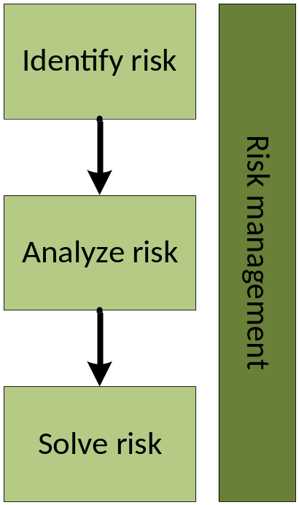
- Identify risk process.
In this step, project manager and team will identify risk may be happen in project. Project manager will make a plan, estimate and prepare resource for risk management.
Project manager will consider the sources may cause problems, find and list all things may be a risk in project (example: requirements, resource, budget…).
The stakeholders will help manager identify what is the real risk base on their expert. Manager will review, classify and list all possible risks in the project.
- Input is manager’s risks list and output is classified risks table.
- Include people: project manager, team members and stakeholders.
- Analyze risk.
In analyze step. Project management will organize meeting to analyze the risks have been confirmed in Identify risk process. The meetings will determine the impact of the risks, sources, the risk level and priority for each of them.
In this step, people will determine spent cost, time and resource if risk become a problem.
- Input of this process is classified table, output of step 1. Output of process is risk analysis report for each of risk (described in following parts).
- Include people: project manager, senior manager, team member.
- Solve risk process.
This step will describes solutions for the risks, impact assessment, cost, people, time required for action, process how to solve if risk occurs.
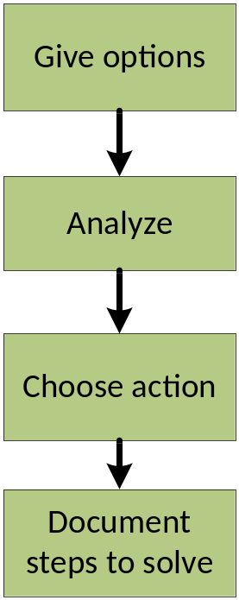
- Give options. Project manager will consult with the professionals related to this risk to give the options for this risk.
- Ignore the risk, as Team members believe it is not likely to occur within the Project Lifecycle
- Validate the risk and request further information that is needed to make a decision
- Decide on a suite of actions to avoid, transfer or mitigate the risk
- Analyze. Project manager will consult with the professionals related to this risk to analyze impact of risk solution if it occurs for each case. Include cost, resource, time and related module. What is happen when we ignore the risk, when avoid, transfer or mitigate the risk or when we face to the risk.
- Choose action. Base on above analysis, project manager will choose action for risk if it occurs.
- Document steps to solve. Project manager will estimates and document steps to solve risk, assign resource and budget for action. In addition, project manager.

- Tracking risk.
Tracking consists of monitoring the status of risks and the actions taken to ameliorate them. Appropriate risk metrics are identified and monitored to enable the evaluation of the status of as well as of risk mitigation plans. Tracking serves as the “watchdog” function of management.

- Control.
Risk control corrects deviations from planned risk actions. Once risk metrics and triggering events have been chosen, there is nothing unique about risk control. Risk control melds into project management and relies on project management processes to control risk action plans, corrects for variations from plans, responds to triggering events, and improves risk management processes.
When all of possible risks in project were defined, project manager monitor project constantly focus on sources may cause problem, those were described in reports.
When the risk occurs, it be called is problem.

- Risk Temple
ID: | Description of risk:
Probability | Note:
Priority
Timeframe:
Strategy:
Status:
Report:

- Top 10 risks in Viking Project.
Refer to the K15T1-Team11-Team Assignment10_Top_10_Risk.xlsx

Risk ID | 1
Risk description | Task does not obvious
Impact | Task does not exactly, actual compare with plan not equal so product output will late. Project late.
Quantitative Evaluation of Risk | Probability | 0.95
 | Impact | 0.85
 | Risk Exposure | 0.8
Plan for managing the risk | 1. Use WBS to identify task.  2. Monitor plan.
Risk Owner | Project Manager
Risk Priority | 1

Risk ID | 2
Risk description | Estimate plan do not exactly
Impact | Price of project will increase compared to the original plan so project may be failed.
Quantitative Evaluation of Risk | Probability | 0.5
 | Impact | 0.85
 | Risk Exposure | 0.35
Plan for managing the risk | - Training skills make plan estimate.  - Use many technical to estimate.: parametric, wide band delphi.
Risk Owner | Project Manager
Risk Priority | 2

Risk ID | 3
Risk description | Lack management change
Impact | Change issues are not resolved so project failure
Quantitative Evaluation of Risk | Probability | 0.8
 | Impact | 0.3
 | Risk Exposure | 0.35
Plan for managing the risk | 1. Define scope of project  2. Monitor and control make decisions on time.
Risk Owner | Project Manager
Risk Priority | 3

Risk ID | 4
Risk description | Requirements and customer's need not enough
Impact | Because output does not meet with customer’s requirement
Quantitative Evaluation of Risk | Probability | 0.9
 | Impact | 0.8
 | Risk Exposure | 0.8
Plan for managing the risk | 1. Improve communication with customer.
Risk Owner | Project Manager
Risk Priority | 4

Risk ID | 5
Risk description | Estimate budget do not exactly
Impact | Because product outline does not meet with customer’s requirement
Quantitative Evaluation of Risk | Probability | 0.4
 | Impact | 0.3
 | Risk Exposure | 0.2
Plan for managing the risk | 1. Estimate budget carefully.  2. Negotiate with investor to add more.  3. Update Budget Plan
Risk Owner | Project Manager
Risk Priority | 5

Risk ID | 6
Risk description | Architect design do not exactly
Impact | Because design does not meet with requirement system so project failure
Quantitative Evaluation of Risk | Probability | 0.7
 | Impact | 0.8
 | Risk Exposure | 0.5
Plan for managing the risk | Must analysis clearly all requirements and review period design
Risk Owner | Project Manager
Risk Priority | 6

Risk ID | 7
Risk description | The scope do not clearly outlined
Impact | Vân viết dùm huyên
Quantitative Evaluation of Risk | Probability | 0.5
 | Impact | 0.4
 | Risk Exposure | 0.4
Plan for managing the risk | Define clearly outlined with customer.
Risk Owner | Project Manager
Risk Priority | 7

Risk ID | 8
Risk description | Lack equipment
Impact | Vân viết dùm huyên
Quantitative Evaluation of Risk | Probability | 0.3
 | Impact | 0.2
 | Risk Exposure | 0.2
Plan for managing the risk | You must define resource before implement project
Risk Owner | Project Manager
Risk Priority | 8

Risk ID | 9
Risk description | Market exchange when product deliverables
Impact | Product of project similar product on market, product had obsolescence and was not accept by market so we cannot sale it. Project failure
Quantitative Evaluation of Risk | Probability | 0.6
 | Impact | 0.6
 | Risk Exposure | 0.4
Plan for managing the risk | Have vision far about trend future
Risk Owner | Project Manager
Risk Priority | 9

Risk ID | 10
Risk description | Developer not skill for develop project and must retraining
Impact | Vân viết dùm huyên
Quantitative Evaluation of Risk | Probability | 0.8
 | Impact | 0.7
 | Risk Exposure | 0.5
Plan for managing the risk | Prepare full skills for implement project
Risk Owner | Project Manager
Risk Priority | 10

